Integers-Introduction
Natural numbers are 1, 2, 3, 4,5 and so on. If we include zero to the collection of natural numbers, we get a new collection of numbers known as whole numbers, that is, 0, 1, 2, 3, 4 and so on.
There are negative numbers also that exist. If we put the whole numbers and the negative numbers together, the new collection of numbers will look like ….-4,-3,-2,-1, 0, 1,2,3,4 and so on. This collection of numbers is known as Integers.
In this collection, numbers above zero - 1, 2, 3... Are said to be positive integers and numbers below zero – 1, – 2, – 3 ... are said to be negative integers.

The integers are represented on the number line in the following way:
- The numbers to the left of zero are negative integers while numbers to the right of zero are positive integers.
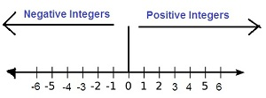
It is important to understand here the order of integers. As we move to the right the value of integers is increasing. Hence 6 is greater than 2, 2 is greater than 1, 0 is greater than -1, -1 is greater than 2 and so on. Therefore, – 3 < – 2, – 2 < – 1, – 1 < 0, 0 < 1, 1 < 2, 2 < 3 so on. By looking at the number line we can see what integers lie between two integers and which the greater integer is. The number line also tells us how much we need to move in order to go from one integer to another.
Problem: Represent the following numbers as integers with appropriate signs.
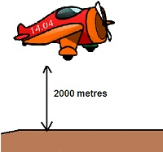
Since aero plane is flying at a height two thousand metre above the ground. Therefore, it will be represented as + 2000.

Problem: Represent the following numbers on a number line: + 5
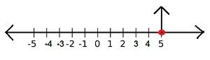
Since the number is +5, it is a positive integer.

Problem: Represent the following numbers on a number line: -1
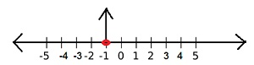
Since the number is -1, it is a negative integer.

Problem: Following is the list of temperatures of five places in India on a particular day of the year.
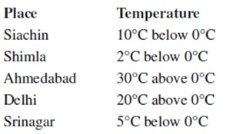
1. Write the temperatures of these places in the form of integers in the blank column.
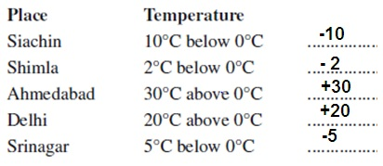
2. Following is the number line representing the temperature in degree Celsius.
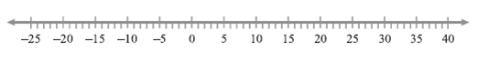
Plot the name of the city against its temperature.
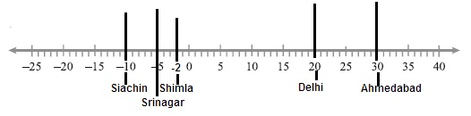
3. Which is the coolest place?
Lower the temperature, cooler is the place. Hence the place with lowest temperature as shown in the number line is Siachin. The temperature in Siachin is -10.

